

C2 – Test Lab

Knowledge Transition Document
For
Assurance Testing Group
(ATG)

Dated: Aug 13, 2010

TABLE OF CONTENTS
1 Introduction 6
1.1 Purpose 6
1.2 Audience 6
1.3 Definitions and Acronyms 7
2 Application Overview 9
2.1 CBOE2 9
2.1.16 C2 New Market Model 15

- Introduction
  - Purpose
The primary objective of this document is to provide:
- Overview of entire C2 System
  - Audience
The intended audiences for this document are:
CBOE and Cognizant Quality Assurance Team
  - Definitions and Acronyms
Acronym | Description
ATG | Assurance Testing Group
AIM | Automated Improvement Mechanism
BART | Booth Automated Routing Terminal
BC | Business Cluster
BOB | Best of Both
BOTR | Best Of The Rest
CAS | Client Application Server
CMi | CBOE Market Interface
COA | Complex Order Auction
COB | Complex Order Book
COPP | CBOE OPRA Participant Processor
CPS | Cross Product Spread
CTMR | CBOE Trade Match system-Rewritten for Unix Platform
CTMi | CBOE Trade Match System Interface
DART | Direct Access Routing Terminal
EOP | Expected Opening Price
EOS | Expected Opening Size
EPW | Exchange Prescribed Width
FE | Front End
GC | Global Cluster
HAL | Hybrid Automated Liasion
HDE | Help Desk Enhancement
HGW | Host Gateway
IPD | Industry Product Database
ISO | Inbound Sweep Order
LSP | Last Sale Price
MDGC | Market Data Global Cluster
MDC | Market Data Cluster
NBBO | National Best Bid Offer
Reg NMS | Regulation National Market System
OEPW | Opening Expected Price Window
OCC | Options Clearing Corporation
OHS | Order Handling System
OPRA | Options Price Reporting Authority
ORS | Order Routing System
PDPM | Preferred Designated Primary Market Maker
PDS | Post Data Server
RCN | Reconfigurable Control Node
SAL | Simplified Automated Liaison
SIAC | Security Industry Automation Corporation
TIPS | Ticker Plant System
TPF | Transaction Processing Facility
UIM | User Input Monitor
XTP | eXtreme Ticker Plant
- Application Overview

  - CBOE2
    - Introduction
With the introduction of Penny Trading, several exchanges introduced Maker / Taker pricing, similar to what is done in the stock markets. Maker / Taker pricing provides a rebate to liquidity providers when they trade against incoming orders. This can result in tighter markets. Maker / Taker pricing has resulted in increased market share for Maker / Taker exchanges.
Among the Maker / Taker and Payment / Preferred models, since it is unclear as to which model will end up being the winner, several exchanges have purchased other exchanges so that they can utilize both models. But in case of CBOE, rather than purchasing another exchange, it has decided to create a separate exchange and acquire a second SRO license from the SEC to setup CBOE2.
The CBOE2 is another options exchange under the CBOE group that is fully electronic and is located in the NY area. CBOE2 is based on the new options linkage and it does not have any trading floor system such as PAR, BOOK OMT, Market Maker Handheld, PTS / TNT, PDS/RCN etc.
Following diagram depicts the CBOE 2 Trading Application Architecture:
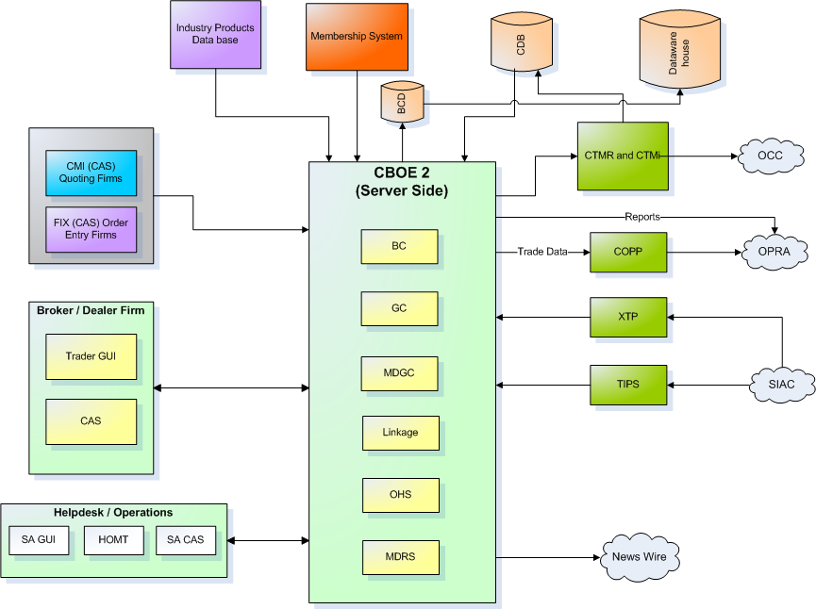

    - CBOE2 – Highlights
  - C2 adopts the existing C1 routing group assignment scheme that uses Post-Station assignment
  - All the existing Trading Properties along with all the likely values from C1 is replicated for C2
  - C2 has MDCAS Groups but has MDX Groups as all Market Data activities are MDX based
  - C2 has BCs named similar to C1 except that they are in the 100 series
  - C2_MAIN runs on all the Development, ATG, and Perf environments session as well in addition to all the existing C1 sessions. C1 and C2 sessions cannot be run simultaneously on the same environment.
  - C2 does not have TPF & PAR.
  - C2 does not have DPM assignments but only RMM assignment for all
  - C2 has HALO turned ‘ON’, as a default setting
  - C2 trades the same products as C1
  - C2 proprietary data are extracted from the ORSA files coming from the OCC
  - If C2 trades an exclusive product, C2 is considered to be an ORSA participating exchange
  - There is no direct access between the respective deepfreeze and Corp environments of C1 and C2
  - In SA GUI, in the ‘User Management’ window Class specific assignment/enablement are allowed using the ‘Classes’ and ‘Enablements’ tabs
  - C2 Bandwidth Allocation is handled and tracked similar to the way it currently is done for C1 (i.e. partly-automated and partly-manual in addition to Rate Limit over-rides through SA GUI)
  - The default order allocation procedure is not just on Price Priority but is Price time pro-rata with Market Turner scheme.
  - Orders that cannot be handled by C2 are CANCELLED similar to DR site workflow
  - Most of the Routing Properties in OHS which involve routing the order to a destination other than TE are set such that those routing properties become irrelevant.
  - C2 does not reject Direct Routed orders and process them like any new incoming order (i.e. trade / book / cancel as applicable)
  - Orders failing Reasonability Edits check are REJECTED
  - C2 has features available through Enhanced Clearing Information Project along with the ability to accommodate the Billing Indicator in the RTC message.
    - New Session for CBOE2
The default session for CBOE 2 is ‘C2_MAIN’. Following are the sub-session for ‘C2_MAIN’:
  - C2_MAIN.all
  - C2_MAIN.corporatebond
  - C2_MAIN.credits
  - C2_MAIN.etf300
  - C2_MAIN.etf315
  - C2_MAIN.index
  - C2_MAIN.interestcomposite
  - C2_MAIN.nasdaq300
  - C2_MAIN.nasdaq315
  - Underlying.all

    - New Billing Types
Along with C1 Billing indicator as ‘Maker - A’, ‘Taker - R’, ‘Flash Response - E’, ‘Flash - F’, ‘Cross - C’, ‘Linked Away - X’, ‘Linked Away Response - L’, ‘ Opening - O’ , ‘Odd Lot Flash - N’ & ‘Odd Lot Flash Response - B’, following are the additional billing indicators to be created to be used both in C1 & C2:
- RESTING = 'Q'
- CROSS_PRICE_IMP = 'S'
- FLASH_PRICE_IMP = 'T'
- FLASH_RESPONSE_PRICE_IMP = 'U'
- MAKER_TURNER = 'V'
- RESTING_TURNER = 'W'

Trade Matrix

Seller  Buyer | A | R | C | F | E | X | L | O | Q | S | T | U | V | W | Billing Types Definitions
A |  | X |  | X (STOCK ONLY) |  |  |  |  |  |  |  |  |  |  | A = MAKER
R | X |  |  |  |  |  |  |  |  |  |  |  | X |  | R = TAKER
C |  |  | X |  |  |  |  |  |  |  |  |  |  |  | C= CROSS
F | X (STOCK ONLY) |  |  |  | X |  |  |  | X |  |  |  | X (STOCK ONLY) | X | F = FLASH
E |  |  |  | X |  |  |  |  |  |  |  |  |  |  | E = FLASH RESPONSE
X |  |  |  |  |  |  | X |  |  |  |  |  |  |  | X = LINKED AWAY
L |  |  |  |  |  | X |  |  |  |  |  |  |  |  | L=LINKED AWAY RESPONSE
O |  |  |  |  |  |  |  | X |  |  |  |  |  |  | O = OPENING TRADE
Q |  |  |  | X |  |  |  |  |  |  |  |  |  |  | Q = RESTING
S |  |  |  |  |  |  |  |  |  | X |  |  |  |  | S = CROSS PRICE IMP
T |  |  |  |  |  |  |  |  |  |  |  | X |  |  | T = FLASH PRICE IMP
U |  |  |  |  |  |  |  |  |  |  | X |  |  |  | U = FLASH RESPONSE PRICE IMP
V |  | X |  | X (STOCK ONLY) |  |  |  |  |  |  |  |  |  |  | V =MAKER TURNER
W |  |  |  | X |  |  |  |  |  |  |  |  |  |  | W = RESTING TURNER

In C2 billing type must be included in following reports:-
  - Fill Reports
  - Trade Reports sent to CTMr
  - Trade History files sent by CTMr to the Data Warehouse
  - RTC Message from CTMr
  - Billing feeders sent by Data Warehouse to Firm58

    - Order types handled differently in C2 compared to C1
- Following contingencies are not accepted in C2
    - Market – If – Touched (MIT) - An order that becomes a MKT order when a product reaches the specified price. This order is similar to a STOP order, however, the buy and sell actions are inverse.
    - Minimum Volume (MIN) - An order that has two quantities specified: the Total Quantity and the Minimum Acceptable Quantity that can be filled where in the fill should at least equal the Minimum Quantity Specified.
    - With Discretion (WD) - An order giving a broker the ability to decide when to buy/sell securities at the best possible price for the customer.
- Orders for products that are Ratio Spreads must be accepted in C2.
- Orders for products that are Cross Product Spreads must be NOT be accepted in C2.
- ‘Not Held’ contingency order must be accepted in C2 where in the contingency is ignored and they are handled like a regular order without any contingency.
- Cross Product Spread Orders must NOT be accepted.
    - Reserve Order
Reserve order is a limit order in which the order originator designates a portion of the order for display and dissemination (called the “display quantity”) and designates a portion of the order in “reserve.” The reserve quantity is not displayed but is available for execution against incoming orders. The ‘display quantity’ is refreshed when it goes below certain threshold value, subject to the condition if some quantities remain in the Reserve Order after execution. The remaining quantity balance would remain in reserve.
Following functionalities are available in both C1 & C2:
- The system are able to handle Simple Orders and complex order with Reserve Order contingency
- For allocations involving Reserve Orders the system use the applicable allocation strategies first against the Displayed Quantities and then attempt to allocate the remainder on the Reserve Quantities but using the same allocation strategies as earlier.
- Reserve Order contingency are not be allowed for AIM orders (i.e. both simple and complex)
- In C1, a Reserve Order must not be allowed to route to PAR or Crowd
- In C1, a Reserve Order must not be accepted on Index Hybrid / BOB Class
- The Display Quantity of the Reserve Order must be replenished and the order rebooked only when the Display Quantity reaches the reserveOrderRefreshSize specified in Order.xml
- C2 needs to support the processing of reserve orders. Allocation needs to work with proper allocation strategies on reserved quantity just like regular order quantity allocation such as maker taker, prorate or price time
    - Trading Support System
- All the Back Office and other trading support systems that are replicated for C2 do not have any dependency on C1 and all their data are separate
- Any replicated system for C2 that has a GUI are changed to indicate that the data being viewed by the user belongs to C2
- The existing Infra System for Back Office Applications (i.e. BOI) are replicated for C2
- Currently in C1, CBOE OPRA Participant Processor (COPP) sends quotes and last sales from CBOE to OPRA in New York. The existing COPP System are replicated for C2. Changes are there in GUI to reflect C2 data.
- Control – M : An independent Control-M environment are created for C2
- There are no direct communications between the Control-M instances at the two sites (i.e. C1 and C2)
    - Membership Systems
- The existing Options Membership System are replicated for C2
- The IMC MAUI system are NOT be replicated for C2
- The No changes existing User Firm Service are replicated for C2
    - Industry Product Database (IPD) System
- The existing IPD System are replicated for C2
- Users have to input products into the C2 IPD separately
- Products in C2 are independent of products in C1 like having their own Class Keys or Product Keys.
    - CBOE Trade Match System (CTMr)
- In CTMr for Trades coming through Batch Load functionality, Trade Corrections are accepted for only the following fields and corrections in the rest all other fields are ignored:
    - Open/Close
    - Origin
    - Mrkt Mkr Acct
    - CMTA
    - Optional Data
  - For C2 changes to the Data Control file are needed which will be determined as firms start connecting to C2
  - Following are the functionalities for CTMr reporting:
    - There must be only one EOD pass
    - CTMr Reports / Files that must be generated in C2 are
      - Matched Trade files
      - Unmatched Trade files
      - Matched report
      - Unmatched report
      - Stats report
      - Audit report
      - Message Audit report
    - CTMr must be sending and receiving files through a different directory structure while evidently indicating that the reports/files belong to C2 and not C1
      - CTMr and CTMi
- The existing CTMr and CTMi System are replicated for C2
- All C2 trades are directed to the new implementation of CTMr and CTMi
- The Users have a different login to CTMi for C2
      - CTMr and RTC
- The existing CTMr and RTC System must be replicated for C2
- CTMr must receive the Billing Indicator from CBOEdirect and it must be transmitted through RTC
- The RTC message must be able to accommodate the Billing Indicator
    - Market Procedure & Planning (MPP)
- The existing MPP System is replicated for C2
- The internet based appointment system used
- Class Quoting Limit (CQL) are set to the highest possible value for that parameter
    - Billing Function
- Firm58's Post-Trade Management System used for billing in C1 to be used for Billing of C2
- Changes are required in functionality for Firm58
- There are no changes required in CBOE GUIs to indicate that it is C2 data
    - Regulatory Function
- Most of the existing Regulatory Applications from C1 must be replicated for C2
    - No changes required in functionality
    - Changes required in GUI to indicate that it is C2 data
    - Data Warehouse
- A separate Data Warehouse are created for all C2 data
- The C2 Data Warehouse reside in the C2 Data Center
- Most of the existing Tables from C1 are replicated for C2
- Replication System - The existing Replication System from C1 are replicated for C2
- An independent Control-D environment are created for C2
- The existing SAS environment from C1 are replicated for C2
- It is to be noted that all tables from C1 are replicated for C2 except the following
    - TIPS – OPRA
    - SIAC SSFutures LTPR
    - DTCC
    - TDF (ILX)
    - Reuters
    - MMET (Market Maker Equity Trade)
    - MMSTK (Market Maker Stock)
- FTAS provide COATS data to the Data Warehouse
- For C2 billing by Firm58's Post-Trade Management System, the Data Warehouse must provide billing feeders with all of the relevant information
    - C2 Website
The web server of C2 is located in C1 premises. The C2 website is part of the cboe.com parent site similar to the way cbsx.com currently is designed. The existing CBOE SCP in C1 is NOT replicated for C2. The existing COB on Web solution is replicated for C2 with GUI indicating that it is C2 data.

    - C2 New Market Model

A new market model has been introduced for CBOE2. Following are the rules of this market model.
      - C2 Matching Algorithm –
The trade allocation will be based the new allocation algorithm. The algorithm that will be used in C2 for trades for simple and complex is Customer priority, PMM and price-time.
The available configuration must be as follows
  - Default Strategy Code = Price Time (1)
  - Prioritized Strategy = Customer (4), Preferred MM

      - Auctions –
- Following auctions for simple orders will not function anymore.
  - HAL
  - AIM
  - SAL
- HALO will function properly with the flash timer being zero.
- There will be no complex order auction such as COA and AIM.
- Autolink functionality must work properly.
      - Strategy –
- As per the new market model, there will be no complex orders in C2
- There will be no complex order book (COB)
- There will be no complex order auction such as COA and AIM
      - Billing Types –
- There will be only Maker and Taker billing types

